Student Name | B. Pravalika
Student Registration Number | 241U1R3008 | Class &Section: CSE-DS
Study Level: UG/PG | UG | Year &Term: II & I
Subject Name | Digital Electronics

Name of the Assessment | Open lab test
Date of Submission | 22-09-2025

Open lab test

LG5
1.Design and implement full adder using half adders.

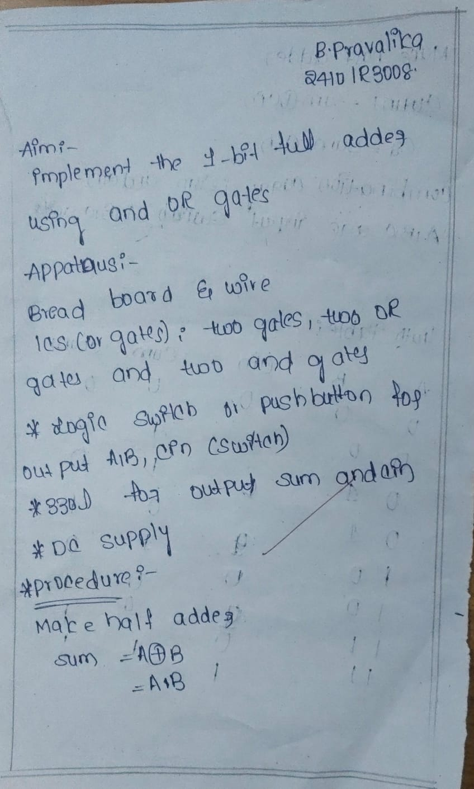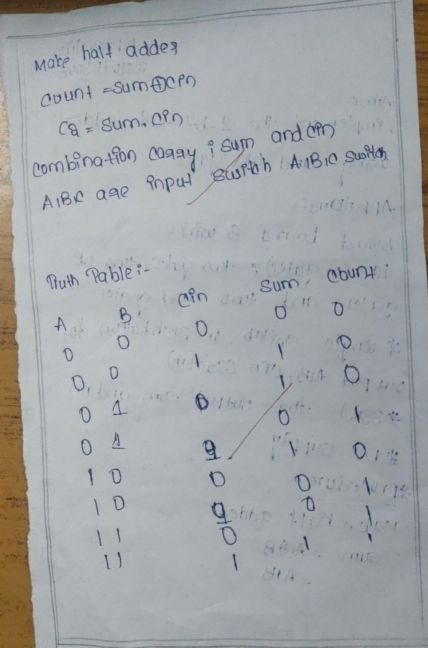

Simulation:
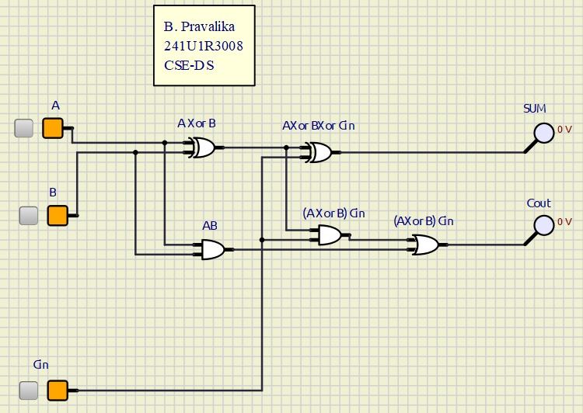

2.Design and implement the Demorgan’s theorem (AB)’=(A’+B’).
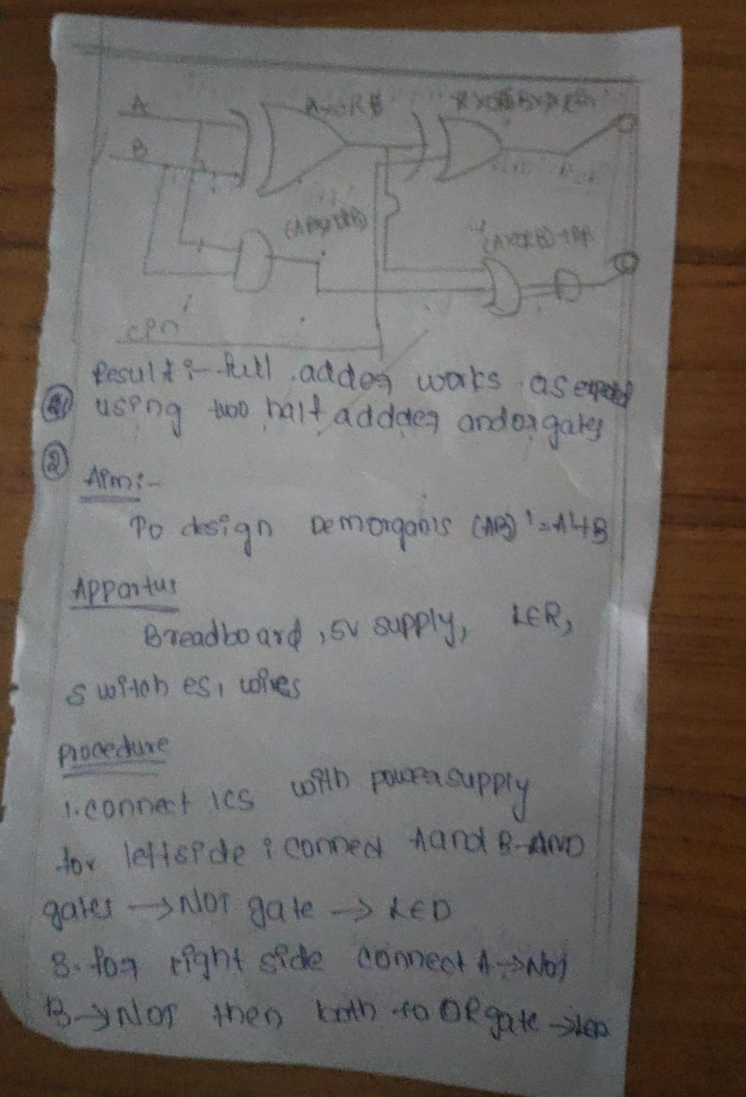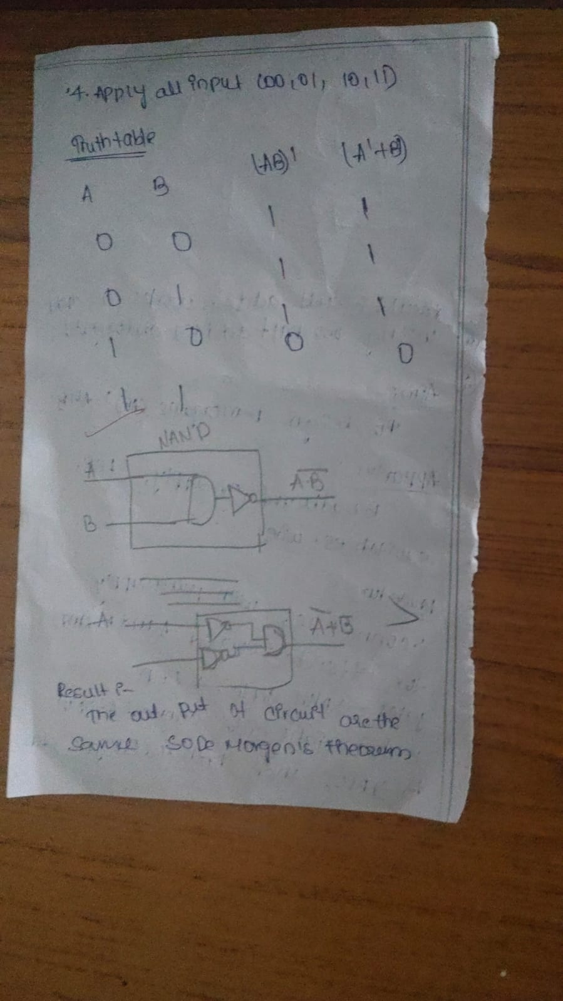

Simulation:

